**Objective:**

The objective of this project is to analyze student scores across different subjects using R programming. The project aims to perform basic statistical analysis, visualize the data, and provide insights into student performance.

**Methodology:**

1. **Data Collection**: A sample dataset containing student names and their scores in Math, Science, and English was created.
2. **Statistical Analysis**: Basic statistical functions such as mean, median, and standard deviation were calculated for each subject.
3. **Data Visualization**: Various visualizations, including bar plots and box plots, were created to represent the score distribution.
4. **Insights and Interpretation**: The results were interpreted to identify trends and patterns in student performance.

**Technologies Used:**

* **Programming Language**: R
* **Libraries**: **dplyr**, **ggplot2**, **tidyr**
* **Environment**: RStudio

**Step-by-Step Implementation**

**Step 1: Set Up Your R Environment:**



**Step 2: Create a Sample Dataset:**

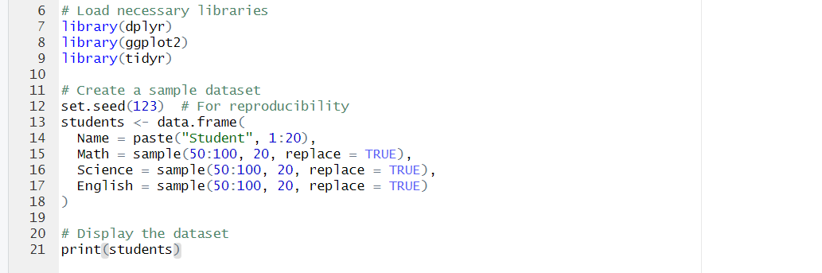

**Step 3: Perform Basic Statistical Analysis:**

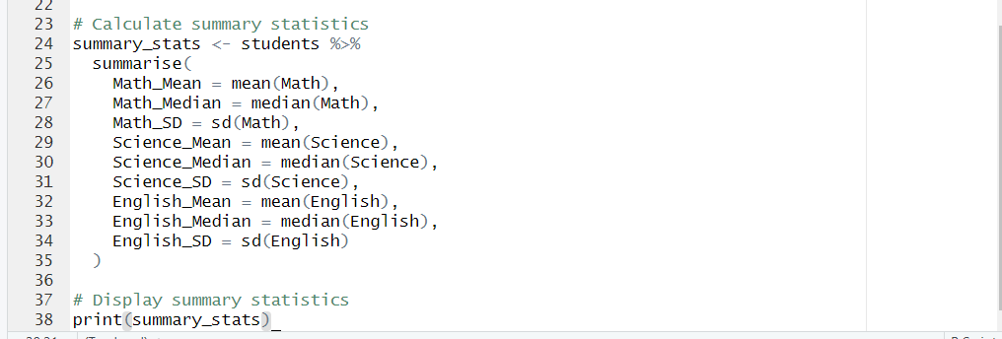

**Step 4: Create Visualizations:**

**1>Bar Plot of Average Scores**

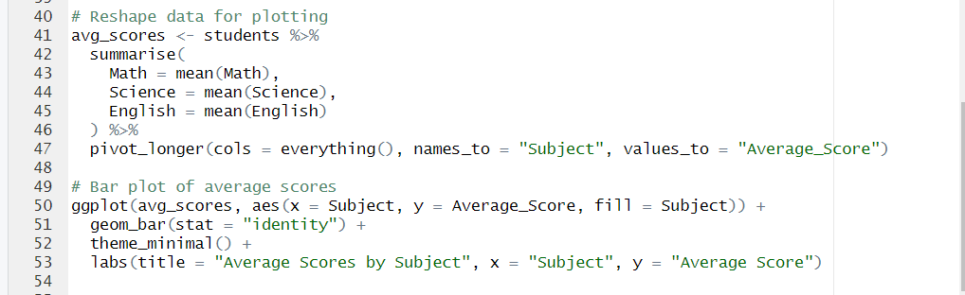

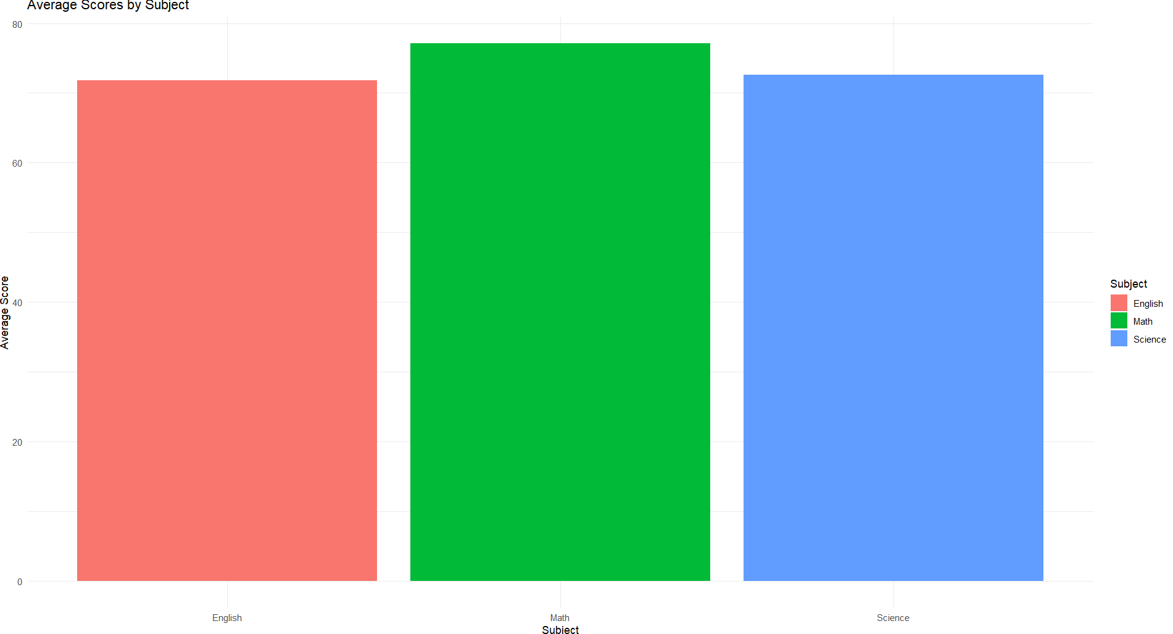

**2>Box Plot of Scores**

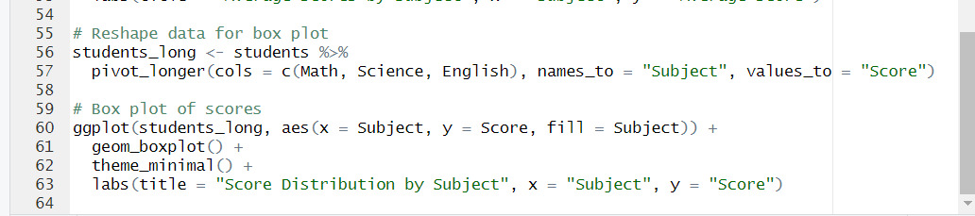

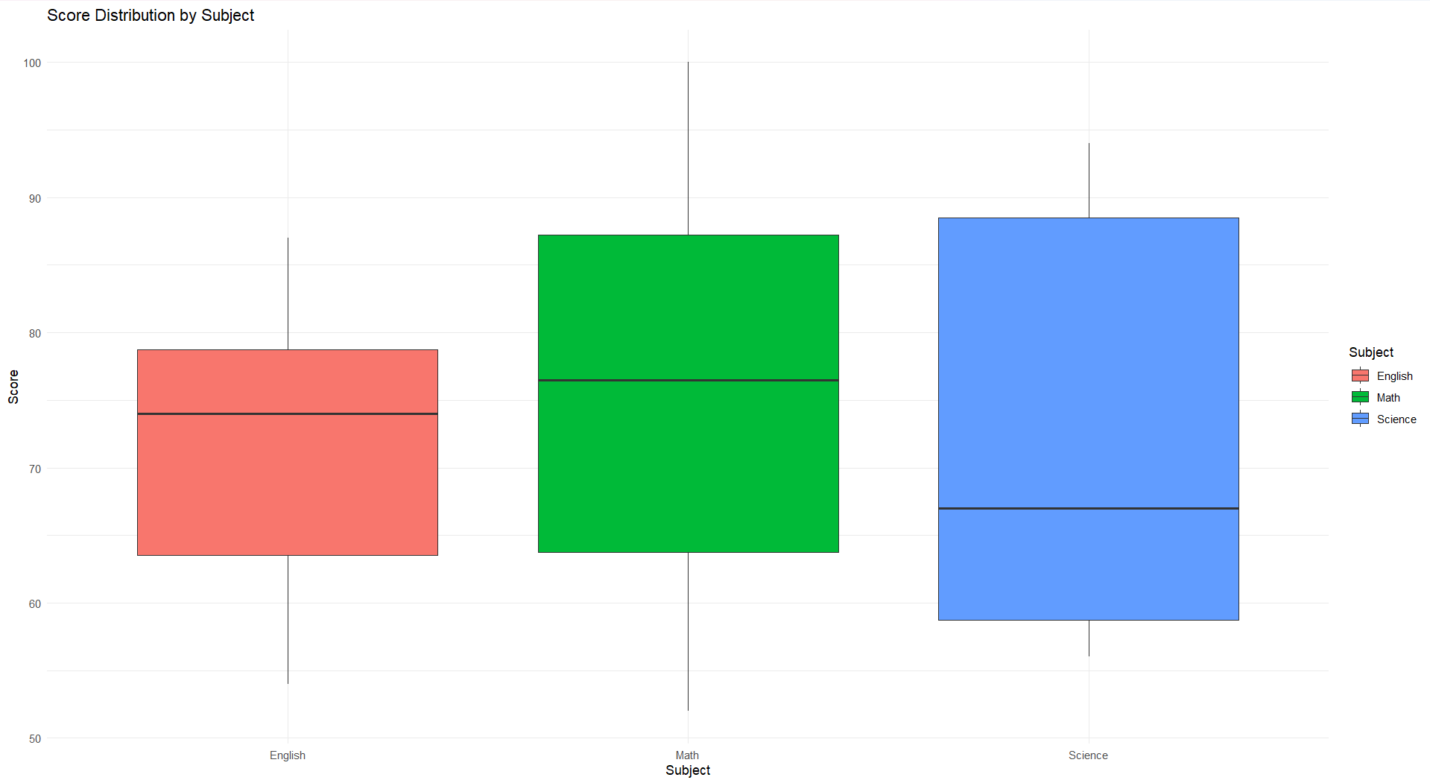

**Conclusion and Insights:**

After completing the analysis and visualizations, we can summarize the findings as follows:

1. **Average Scores**: The bar plot provides a clear visual representation of the average scores across subjects, allowing us to quickly identify which subjects students performed best in.
2. **Score Distribution**: The box plot illustrates the spread of scores for each subject, highlighting any outliers and the overall distribution of scores.
3. **Highest and Lowest Scorers**: Identifying the highest and lowest scorers in each subject can help educators understand individual student performance